EXPT NO: 7 | IMPLEMENTATION OF A SIMPLE AUTOENCODER FOR DIMENSIONALITY REDUCTION AND FEATURE LEARNING
DATE: 02-11-2026

PRE-LAB QUESTIONS (PROVIDE BRIEF ANSWERS TO THE FOLLOWING QUESTIONS)

1. Discuss the roles of the Encoder and Decoder in an Autoencoder.
The Encoder compresses the input data into a smaller representation called the latent space. The Decoder reconstructs the original data from this compressed representation. Together, they help the Autoencoder learn important features and patterns from the input data.

2. Explain how an Autoencoder performs dimensionality reduction.
An Autoencoder reduces dimensionality by converting high-dimensional input data into a smaller latent representation. The Encoder removes unnecessary information while retaining important features. This compressed representation requires fewer dimensions while preserving essential information.

3. Why is a bottleneck layer important in an Autoencoder architecture?
The bottleneck layer is the smallest layer in an Autoencoder architecture. It forces the network to learn and retain only the most important features of the input data. It helps reduce dimensionality, remove redundant information, and create an efficient data representation.

AIM
To implement and train a simple Autoencoder for dimensionality reduction and feature learning by compressing input data into a lower-dimensional representation and reconstructing the original data from the learned features.

SOFTWARE REQUIREMENTS
- Python
- TensorFlow / Keras / PyTorch
- Google Colab
- GitHub
- NumPy
- Matplotlib
- Pandas
- Scikit-learn

OBJECTIVES
Students will be able to:
- Understand the architecture and working of an Autoencoder.
- Identify the functions of the Encoder, bottleneck, and Decoder.
- Prepare and normalize input data for Autoencoder training.
- Build and train an Autoencoder using a suitable dataset.
- Perform dimensionality reduction through latent-space representations.
- Evaluate reconstruction performance using suitable loss metrics.
- Visualize reconstructed data and analyze the learned features.
- Document the experiment and manage the notebook using GitHub.

PROCEDURE
PART A: DATASET PREPARATION
Perform the following tasks:
- Load a suitable dataset, such as the MNIST handwritten digits dataset.
- Explore the dataset and examine sample input images.
- Identify the dimensions and data types of the input samples.
- Normalize the pixel values to a suitable range, such as 0 to 1.
- Reshape the input images into one-dimensional vectors if using a Dense Autoencoder.
- Split the dataset into training and testing datasets.
- Use the input data as both the input and target output for reconstruction.
- Display a sample of the original images.

# ============================================
# PART A: DATASET PREPARATION
# AUTOENCODER
# Name: Mithunjai. E
# Roll Number: 24BAD071
# ============================================

import numpy as np
import matplotlib.pyplot as plt
import pandas as pd
import tensorflow as tf

from tensorflow.keras.datasets import mnist

# Load MNIST dataset
(x_train, y_train), (x_test, y_test) = mnist.load_data()

# Display dataset information
print("Training data shape:", x_train.shape)
print("Testing data shape:", x_test.shape)
print("Data type:", x_train.dtype)
print("Number of training samples:", len(x_train))
print("Number of testing samples:", len(x_test))

# Display sample images
plt.figure(figsize=(10, 5))

for i in range(10):
plt.subplot(2, 5, i + 1)
plt.imshow(x_train[i], cmap='gray')
plt.title("Digit: {}".format(y_train[i]))
plt.axis('off')

plt.suptitle("Original MNIST Images")
plt.show()

# Normalize pixel values between 0 and 1
x_train = x_train.astype('float32') / 255.0
x_test = x_test.astype('float32') / 255.0

# Reshape images into one-dimensional vectors
x_train = x_train.reshape(-1, 784)
x_test = x_test.reshape(-1, 784)

# Input and target are the same for autoencoder
x_train_auto = x_train
x_test_auto = x_test

# Display normalized data information
print("\nAfter Normalization:")
print("Training shape:", x_train_auto.shape)
print("Testing shape:", x_test_auto.shape)
print("Minimum pixel value:", np.min(x_train_auto))
print("Maximum pixel value:", np.max(x_train_auto))

print("\nPART A COMPLETED SUCCESSFULLY")
Output:
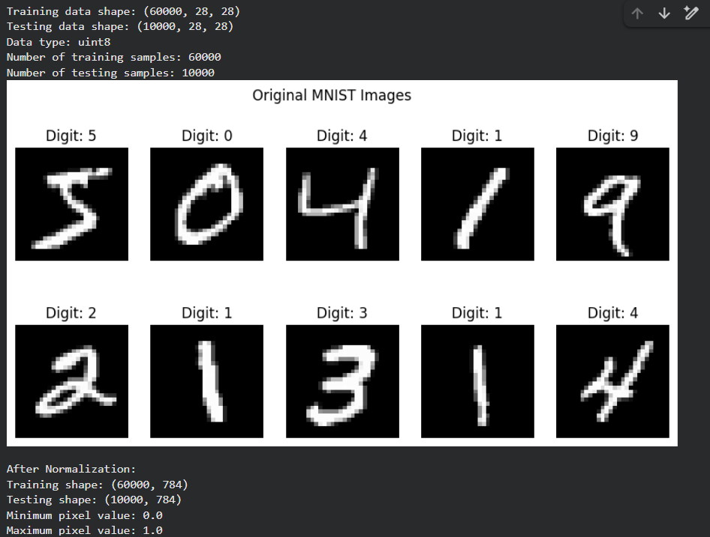

PART B: IMPLEMENTING THE AUTOENCODER MODEL
Perform the following tasks:
- Define the input layer based on the dimensions of the dataset.
- Create an Encoder using one or more Dense layers.
- Introduce a bottleneck layer with fewer neurons than the input layer to learn a compact representation.
- Create a Decoder to reconstruct the input from the bottleneck representation.
- Use a suitable activation function, such as ReLU for hidden layers and Sigmoid for normalized image reconstruction.
- Combine the Encoder and Decoder to construct the complete Autoencoder.
- Compile the model using an appropriate optimizer, such as Adam, and a reconstruction loss function, such as Mean Squared Error (MSE).
- Display the model architecture and model summary.

Code:
# ============================================
# PART B: IMPLEMENTING AUTOENCODER MODEL
# Name: Mithunjai. E
# Roll Number: 24BAD071
# ============================================

from tensorflow.keras.layers import Input, Dense
from tensorflow.keras.models import Model

# Input layer
input_layer = Input(shape=(784,), name="Input_Layer")

# Encoder
encoder_layer1 = Dense(128, activation='relu')(input_layer)
encoder_layer2 = Dense(64, activation='relu')(encoder_layer1)

# Bottleneck layer
bottleneck = Dense(32, activation='relu',
name="Bottleneck")(encoder_layer2)

# Decoder
decoder_layer1 = Dense(64, activation='relu')(bottleneck)
decoder_layer2 = Dense(128, activation='relu')(decoder_layer1)

# Output layer
output_layer = Dense(784, activation='sigmoid')(decoder_layer2)

# Complete Autoencoder
autoencoder = Model(input_layer, output_layer)

# Separate Encoder model
encoder = Model(input_layer, bottleneck)

# Compile model
autoencoder.compile(
optimizer='adam',
loss='mean_squared_error'
)

# Display model summary
print("AUTOENCODER MODEL SUMMARY")
autoencoder.summary()

print("\nENCODER MODEL SUMMARY")
encoder.summary()

# Display architecture
tf.keras.utils.plot_model(
autoencoder,
show_shapes=True,
show_layer_names=True,
to_file='autoencoder_architecture.png'
)

# Display architecture image
from IPython.display import Image, display

display(Image(filename='autoencoder_architecture.png'))

print("\nPART B COMPLETED SUCCESSFULLY")
Output:
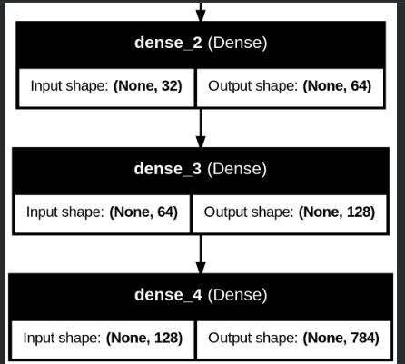

PART C: MODEL TRAINING AND PERFORMANCE EVALUATION
Perform the following tasks:
- Train the Autoencoder using the prepared training dataset.
- Use the original input samples as target outputs.
- Validate the model using validation data or the testing dataset, as appropriate.
- Record:
  - Training loss
  - Validation loss
- Evaluate the trained model using the test dataset.
- Calculate the reconstruction Mean Squared Error (MSE).
- Plot the training and validation loss against the number of epochs.
- Compare the original input images with their reconstructed outputs.

Code:
# ============================================
# PART C: MODEL TRAINING AND EVALUATION
# Name: Mithunjai. E
# Roll Number: 24BAD071
# ============================================

# Train the autoencoder
history = autoencoder.fit(
x_train_auto,
x_train_auto,
epochs=20,
batch_size=256,
shuffle=True,
validation_data=(x_test_auto, x_test_auto)
)

# Evaluate the model
test_loss = autoencoder.evaluate(
x_test_auto,
x_test_auto,
verbose=0
)

print("Test Reconstruction Loss (MSE):", test_loss)

# Predict reconstructed images
reconstructed_images = autoencoder.predict(x_test_auto)

# Calculate Mean Squared Error
mse = np.mean(
np.square(x_test_auto - reconstructed_images)
)

print("Reconstruction Mean Squared Error:", mse)

# Plot training and validation loss
plt.figure(figsize=(8, 5))

plt.plot(history.history['loss'],
label='Training Loss')

plt.plot(history.history['val_loss'],
label='Validation Loss')

plt.title('Training and Validation Loss')
plt.xlabel('Epochs')
plt.ylabel('Mean Squared Error')
plt.legend()
plt.grid()
plt.show()

# Compare original and reconstructed images
plt.figure(figsize=(15, 5))

for i in range(10):

# Original images
plt.subplot(2, 10, i + 1)
plt.imshow(x_test_auto[i].reshape(28, 28),
cmap='gray')
plt.title("Original")
plt.axis('off')

# Reconstructed images
plt.subplot(2, 10, i + 11)
plt.imshow(reconstructed_images[i].reshape(28, 28),
cmap='gray')
plt.title("Reconstructed")
plt.axis('off')

plt.tight_layout()
plt.show()

print("\nPART C COMPLETED SUCCESSFULLY")

Output:
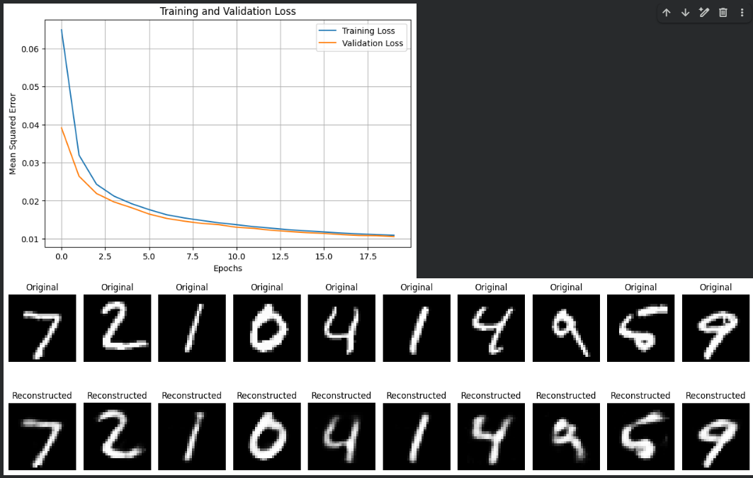

PART D: DIMENSIONALITY REDUCTION, FEATURE VISUALIZATION AND EXPERIMENT MANAGEMENT

Perform the following tasks:
- Provide new movie-review sentences as input to the trained LSTM model.
- Extract latent-space representations of test samples using the trained Encoder.
- Compare the dimensions of the original input data and compressed representations.
- Visualize the latent representations using a suitable plot.
- Reconstruct selected test samples using the Decoder and compare them with the original images.
- Record observations on dimensionality reduction and reconstruction quality.
- Document the observations and upload the notebook to GitHub.

Code:
# ============================================
# PART D: DIMENSIONALITY REDUCTION AND
# FEATURE VISUALIZATION
# Name: Mithunjai. E
# Roll Number: 24BAD071
# ============================================

from sklearn.decomposition import PCA

# Extract latent representations using Encoder
latent_features = encoder.predict(x_test_auto)

print("Original Data Dimensions:",
x_test_auto.shape)

print("Compressed Data Dimensions:",
latent_features.shape)

# Display dimensionality reduction
print("\nDimensionality Reduction:")
print("Original dimensions:", 784)
print("Latent dimensions:", 32)
print("Dimensions reduced by:", 784 - 32)

# Visualize latent representations using PCA
pca = PCA(n_components=2)

latent_2d = pca.fit_transform(latent_features)

plt.figure(figsize=(10, 7))

scatter = plt.scatter(
latent_2d[:, 0],
latent_2d[:, 1],
c=y_test,
cmap='tab10',
s=5
)

plt.colorbar(scatter, label='Digit Class')
plt.title('Visualization of Latent Space using PCA')
plt.xlabel('Principal Component 1')
plt.ylabel('Principal Component 2')
plt.show()

# Reconstruct selected test samples
selected_samples = x_test_auto[:10]

compressed_samples = encoder.predict(selected_samples)

decoded_samples = autoencoder.predict(selected_samples)

# Display original and reconstructed samples
plt.figure(figsize=(15, 5))

for i in range(10):

plt.subplot(2, 10, i + 1)
plt.imshow(selected_samples[i].reshape(28, 28),
cmap='gray')
plt.title('Original')
plt.axis('off')

plt.subplot(2, 10, i + 11)
plt.imshow(decoded_samples[i].reshape(28, 28),
cmap='gray')
plt.title('Reconstructed')
plt.axis('off')

plt.tight_layout()
plt.show()

# Calculate reconstruction error for selected samples
sample_mse = np.mean(
np.square(selected_samples - decoded_samples)
)

print("Selected Samples Reconstruction MSE:", sample_mse)

# Save latent features
np.save('latent_features.npy', latent_features)

# Save trained autoencoder model
autoencoder.save('autoencoder_model.keras')

# Save encoder model
encoder.save('encoder_model.keras')

# Create experiment results table
results = pd.DataFrame({
'Parameter': [
'Original Dimensions',
'Latent Dimensions',
'Training Samples',
'Testing Samples',
'Epochs',
'Reconstruction MSE'
],
'Value': [
784,
32,
len(x_train_auto),
len(x_test_auto),
len(history.history['loss']),
mse
]
})

print("\nEXPERIMENT RESULTS")
print(results)

# Save results as CSV
results.to_csv('autoencoder_results.csv', index=False)

print("\nSaved Files:")
print("1. autoencoder_model.keras")
print("2. encoder_model.keras")
print("3. latent_features.npy")
print("4. autoencoder_results.csv")

print("\nPART D COMPLETED SUCCESSFULLY")

Output:
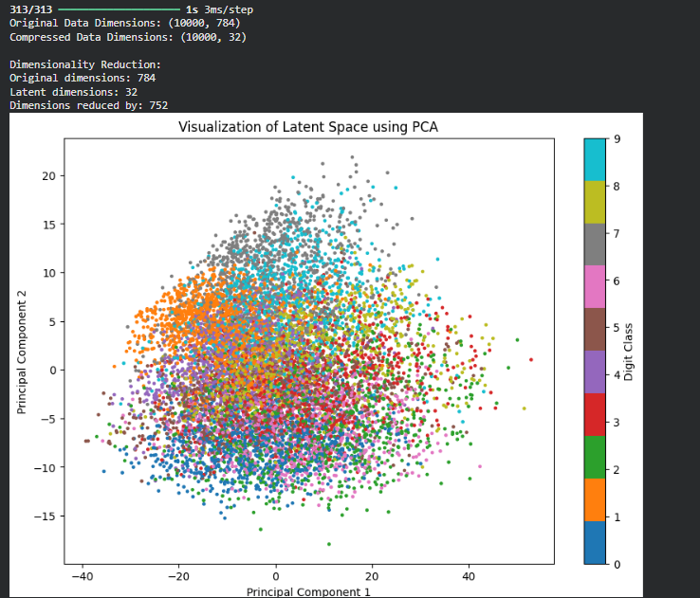
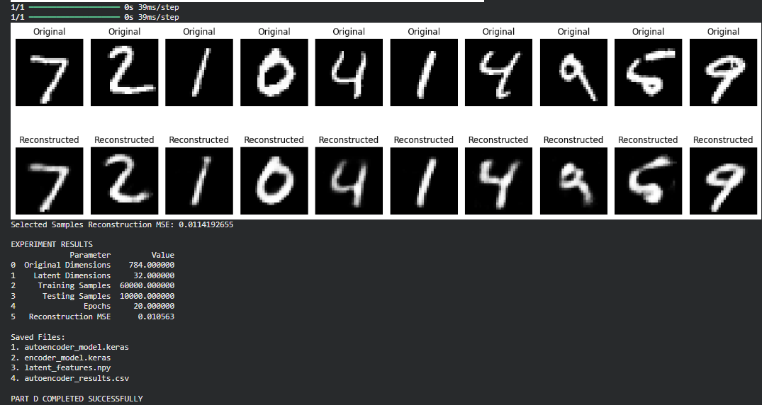

POST-LAB QUESTIONS (PROVIDE BRIEF ANSWERS TO THE FOLLOWING QUESTIONS)

1. Explain the significance of reconstruction loss in training an Autoencoder.
Reconstruction loss measures the difference between the original input and the reconstructed output. It helps the Autoencoder learn meaningful features by minimizing reconstruction errors. Lower reconstruction loss indicates better reconstruction quality.

2. State one advantage of Autoencoders over traditional dimensionality-reduction techniques.
Autoencoders can learn complex, non-linear patterns in data, whereas traditional techniques like PCA mainly capture linear relationships. This allows Autoencoders to learn more meaningful representations of complex datasets.

3. Discuss two practical applications of Autoencoders apart from dimensionality reduction.
- Anomaly Detection: Autoencoders identify unusual data by detecting high reconstruction errors, useful in fraud detection and network security.
- Image Denoising: Autoencoders remove noise from corrupted images and reconstruct clearer, improved images.

ASSESSMENT
Description | Max Marks | Marks Awarded
Pre Lab Exercise | 5
In Lab Exercise | 10
Post Lab Exercise | 5
Viva | 10
Total | 30
Faculty Signature

